Which statement describes your: | ☑the definition that best describes your current situation for each category |  |  |  |  | To improve my situation I need:
Feelings today? | ⬜  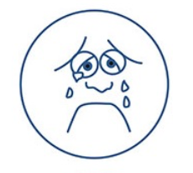 | ⬜  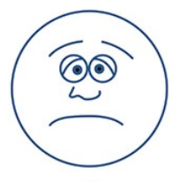 | ⬜  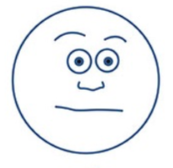 | ⬜ | ⬜
Housing? | ⬜  I am sleeping on the streets or somewhere not considered housing. | ⬜  I am staying in shelter or at someone else's’ home on a temporary basis. | ⬜  I have housing but it is short-term (less than a year) or unaffordable. | ⬜  I have affordable housing but it is unstable, unsafe, and/or unclean. | ⬜  I have safe, adequate, and affordable housing.
Access to Health  Care? | ⬜  I don’t have health insurance (including MAP and don’t get health care. | ⬜  I don’t have health insurance or MAP, but go to the emergency room or call EMS if I need help. | ⬜  I have health insurance, but I am still unable to access a doctor or other care provider. | ⬜  I have health insurance and a doctor but have trouble seeing them or meeting all my unique needs. | ⬜  I have a regular doctor and am able to see specialists if needed.
Economic Stability? | ⬜  I have no income, job, or benefits. | ⬜  I do day to day labor that is unpredictable and does not have benefits. | ⬜  I do seasonal or part-time work, or have limited benefits that don’t always cover basic needs. | ⬜  I work full-time with limited pay and/or have benefits that cover my basic needs. | ⬜  I have permanent employment. It provides enough income so I can save money for emergencies.
Food? | ⬜  I rely on free food. | ⬜  I can sometimes buy food, but have no way to prepare or store it. | ⬜  I can buy food but need some help from a food pantry or charity. | ⬜  I can meet my food needs without help from a nonprofit, but can not always buy food I want. | ⬜  I can buy any food I want whenever I need it.
Which statement describes your: | ☑ the definition that best describes your current situation for each category |  |  |  |  | To improve my situation I need:
Mental Health? | ⬜  I experience difficulty in day-to-day life because of my mental health. It makes daily functions difficult (i.e. making an appointment). | ⬜  I have regular symptoms that occur and sometimes make it hard to function. | ⬜  I have some symptoms, once in awhile. They do not usually impact my daily functions. | ⬜  I experience some stress. It rarely impair my daily functions. | ⬜  I almost never have symptoms. My daily problems or concerns do not impact my daily functioning.
Transportation? | ⬜  I have no access to transport. | ⬜  Transportation is present but there are barriers. It is unreliable and/or too expensive. | ⬜  Transportation is affordable. It can be limited and/or inconvenient. | ⬜  Transportation meets basic daily travel needs. | ⬜  I have transportation options. They are reliable and flexible.
Drug or Alcohol Use? | ⬜  I use drugs and alcohol to function. | ⬜  Drugs or alcohol causes me to avoid or neglect normal life activities regularly. | ⬜  I use and it can cause some social, occupational, emotional, or physical problems. | ⬜  I use drugs and alcohol sometimes but there are no issues related to my use. | ⬜  I do not use drugs or alcohol.

